Training Manual
Puppy Pre-K
with Heather Witt
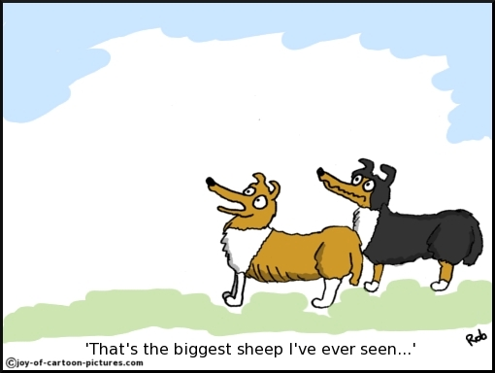

heather@heatherwitt.com
203.257.0604

Dog’s call name: __________________
This is the name by which you introduce and refer to the dog.
Ex. “Where is ____________________’s leash?”

Dog’s command name or word: ___________________
This is the word or name that proceeds all commands. It is never used as a negative or for reference.
Ex. “_______________, sit.”

The idea is to keep the dog’s sensitivity to their command name/word by using it only for commands and referring to the dog by their call name.

Dog’s bridge word:_________________
This is a word used to mark behaviors to be reinforced with food. It is not praise. It should be short, upbeat, and specific to training. It is used in the training approach called shaping and is interchangeable with a clicker.
Examples are great, super, score, ta da.

Impulse Control
The goal is to create a less reactive and impulsive dog. To do this we reward calm behavior, eye contact, and restraint.
Scenarios to practice impulse control:
- Exiting crate, car, house wk1____ wk2____ wk3____ wk4____
- Greeting people and dogs wk1____ wk2____ wk3____ wk4____
- Manners around food wk1____ wk2____ wk3____ wk4____
- Appropriate play with people and toys
Wk1____ wk2____ wk3____ wk4____

Impulse control can be achieved by preventing dog’s access to the goal or object of interest until dog offers an automatic sit or down and eye contact. Reinforcement can be in the form of play, petting, food, or access to object or activity of interest.

*Food for thought: If your expectations are too high there will not be any opportunities for reinforcement. Begin with achievable goals and then build and refine.

Play the impulse control/treat game. Steps:
- Food in closed hand. Ignore all attempts by dog to get food. The moment the dog looks away or backs off from your hand, BT. (Always make sure to deliver food to dog rather than letting the dog move toward food.)
- When dog can ignore or retreat in closed hand and make eye contact. BT.
- Food is in open hand. If dog moves toward food, close hand. When dog moves back, BT.
- Food is in open hand. When dog ignores food and makes eye contact, BT.
- Food is on floor. If dog moves toward food, cover with hand or foot. When dog ignores food, BT.
- Food is on floor. When dog ignores food and makes eye contact, BT.
- Drop food on floor. If dog approaches, cover. If dog doesn’t approach, BT.
- Drop food on floor. When dog ignores food and makes eye contact, BT.
Practice wk1____ wk2____ wk3____ wk4____

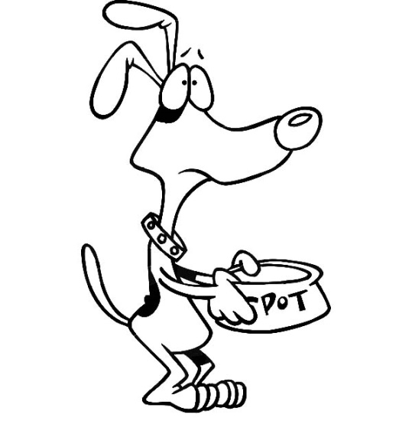

I suggest that pups not be fed out of a food dish. Feeding them this way is a wasted opportunity at a critical stage in their development. Consider feeding the pups their food throughout the day as training treats. Measure the appropriate amount of food out and BT all good behavior. Examples would be loose leash, attention, calm demeanor, approaches and recalls, settling on bed, entering crate, calm greetings. The list is almost endless.
Any leftover food can be put in a puzzle toy to keep the dog busy when you need to leave or get other things done.

Respect and Self-Sufficiency
The dog needs to learn to respect our personal space. We have a number of ways to aid the dog in learning to be respectful.
- The forearm block
- The stand and block
- The walk thru
Concurrently, we need to respect the dog and their personal space. If we are going to disturb a resting dog, we need to make that a positive experience, ie: Treats!
Resting Scenarios:
- Crate or dog bed
- At rest anywhere
Options for Interaction:
- Invite dog to you. If they don’t approach, leave them be.
- Disturb them but make it positive (Children should ask parental permission)
- Clip the leash on to move them, or do “touch”
In order for dogs to be self-sufficient, they cannot be in control of when they get attention, play, food, access.
To reinforce calm behavior, make that the gateway to all things positive.
Ignore all their attempts to control or manipulate attention.
Meet their needs, not their demands.
*Food for thought:
Be proactive, not reactive. Look for opportunities to reward dogs or they will find ways to pull the focus on to them with behaviors like barking, object theft, jumping, pawing, nudging, whining.

FOCUS:
- Having the dog check in with you in order to gain access to valuable activities or objects
- Having the dog ignore stimulation and attend to you
Can be brought about by asking for the attention with eye contact and/or waiting for the dog to offer eye contact on their own. Commanded eye contact can be taught through shaping.
Command for eye contact is ________________________________
“Mother, may I?” eye contact is taught by offering access at the time of focus.
Scenarios to practice:
Doors 2____ 3____ 4____
Thrown toy 2____ 3____ 4____
Greetings 2____ 3____ 4____
TAKING HIGH VALUE OBJECTS OR OPPORTUNITIES AWAY:
This should be done repeatedly, and the object returned or activity returned regularly.
- Come inside to go outside
- Relinquish bone/stick/ball in order to get it returned
To take high value objects away from a “runner,” start by rewarding them for not retreating. Gradually get closer before they earn their high-value reward. Do not snatch at object, try to pull it out, or chase dog.
Have them wear a dragging line and do a valuable exchange if you need to really get something as you train this behavior.
Play the “Can I see that?” game daily with different objects, with the plan on returning them as often as possible.
“Can I see that?” week 2 ______, week 3 ______, week 4 ______

LEASH INTRODUCTION:
Of utmost importance, supremely significant rule: Do not apply steady pressure to the dog’s leash.
Command for leash walking is: _________________________
If dog pulls on you, apply gentle, brief pressure to return dog to a slack leash state.
Reward often for the slack leash, with praise, treats, and access.
While walking, if dog pulls:
Level 1: Freeze. If tension continues, apply your gentle, brief pressure.
Level 2: Turn and walk the opposite direction until dog is compliant for 5 plus steps before returning to your original path or approaching objects of interest.

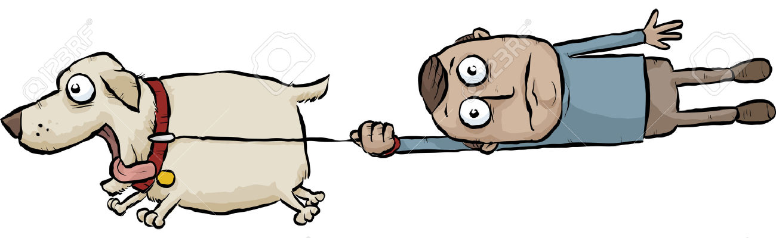

GREETINGS:
To People: Appropriate greetings are important. Not jumping, mouthing, or even approaching uninvited are important considerations.
To teach your dog to greet properly, prevent them from approaching until they “check in.” Then give your greeting phrase “______________________________”
I like “go say hi!”
Technique: Approach with dog and reward for anything not jumping or mouthing. If dog does jump or mouth, say “oops” and retreat with them. When they refocus on you, try again.
To dogs: Adult dog to adult dog greetings should be 2 ½ seconds long, and should be done circuitously when possible. Do not greet an overly excited dog. Wait for calmer behavior. To approach an overly anxious dog, it’s better they be allowed to approach you.
If any dog gets too pushy, step between to separate. Do not pull away or reach in, as this could trigger aggression or get someone injured.
Pushy Behavior:
- Neck over back
- Mounting
- Too forceful sniffing of inguinal areas.
These rules apply to dog park and street encounters. Dogs living together get more leeway. Don’t ignore a bully; block them.
Take It / Drop It:
- Offer object. As dog grabs, say “Take it” and BT. Dog will have to release to get treat.
- Offer object and as dog grabs say “Take it.” As they spit it out, say “Drop it.”
- Teach them to hold longer by quietly re-offering if they spit out prematurely.
- Make sure your treat has more value than the ‘take it’ object.

Practice Take It / Drop It Week 4________________
Week 5________________
LEAVE IT:
- Stand on leash or brace arm so dog can not quite reach object you want them to release. When they take attention of item, BT.
- Repeat, but as they turn away, say “Leave it.” BT
- Spot check with random objects. Use leash to gently turn away as needed.

